Morse Decoder

|  |  |
| --- | --- |
| **Version** |  |
| **Issue Date:** |  |

|  |  |
| --- | --- |
| **Document Number:** |  |
| **Status:** |  |
| **CDRL No:** |  |
| **DOORS™ Module Reference:** | [N/A] |
| **Classification:** |  |

Sean Winfree

Table of Contents

1.0 Introduction 3

2.0 Morse Code Timing 3

3.0 Constant Wave 4

4.0 References 6

**Table of Figures**

Figure 1: Dit and Dah Relative Timing 3

Figure 2: Character and Word Relative Spacing 4

Figure 3: Morse Code Time Domain 4

Figure 4: Morse Code (SNR = 10dB) 5

Figure 5: Performance of Morse Decoder 6

1. Introduction

The HF CW standard (also known as Morse code) is well known, and consists of a continuous phase – constant wave (CW) signal modulated as high or low to indicate the presence of a symbol. This mode of communication encodes ASCII characters as a series of bits with varying length and spacing. Short bits are known colloquially as "dits" (or dots) and will be represented here as a "." while long bits are known colloquially as "dahs" (or dash) and will be represented here as "dahs".

We use the well accepted international Morse Code standards, repeated here for convenience: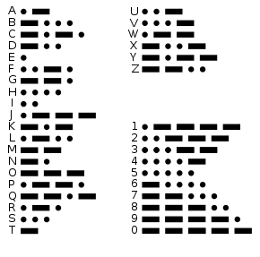

1. Morse Code Timing

Transmission speed, bit length and bit spacing define completely the aspects of the signaling. All other elements are defined as multiples of the dit length. Transmission speed in standard CW is measured in Words Per Minute (WPM). In our application, received WPM is restricted to be a single speed. The length of the average word is assumed to be 5 characters totaling 50 units. Using this value, we can compute the dit length as 1.2s/WPM and the dah length as three times this unit length. The in-character spacing is equal to one dit.



**WPM = 1.2s/(Dits per second)**

CW can be decoded by collecting short and long bits separated by in-character spaces (of length single dah) where characters may be separated by recognizing a between-word space (of length three dahs).

For example, a speed of 10WPM has an dit on time of 1.2/12 = 0.1 second. The subsequent dah length is then 0.3 seconds. Each on state is separated by the length of a dit, or 0.1 seconds in this example.

Figure : Dit and Dah Relative Timing

Figure 2 details, and between-character (letter) spacing is equal to three dits. The pausing between words is seven dits.



Figure : Character and Word Relative Spacing

1. Morse Encoding

The Morse on state is a Constant Wave (CW) of a defined frequency, fsig. The modulation (or carrier) frequency used to transmit the Morse code over HF is called the fcarrier. Figure 3 shows an example of a Morse code at baseband prior to being modulated by the carrier frequency.

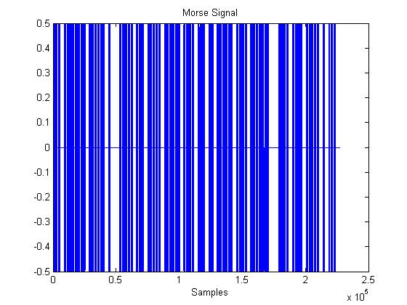

Figure : Morse Code Time Domain

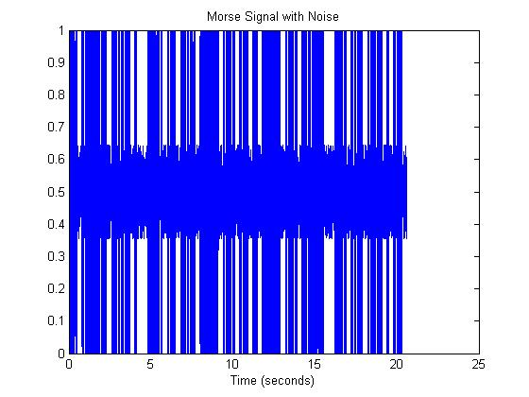

Figure : Morse Code (SNR = 10dB)

1. Morse Decoding

The received HF is converted to baseband by the HF transceiver.

* 1. Hilbert Transform

The Hilbert Transform is …

* 1. Filtering

The

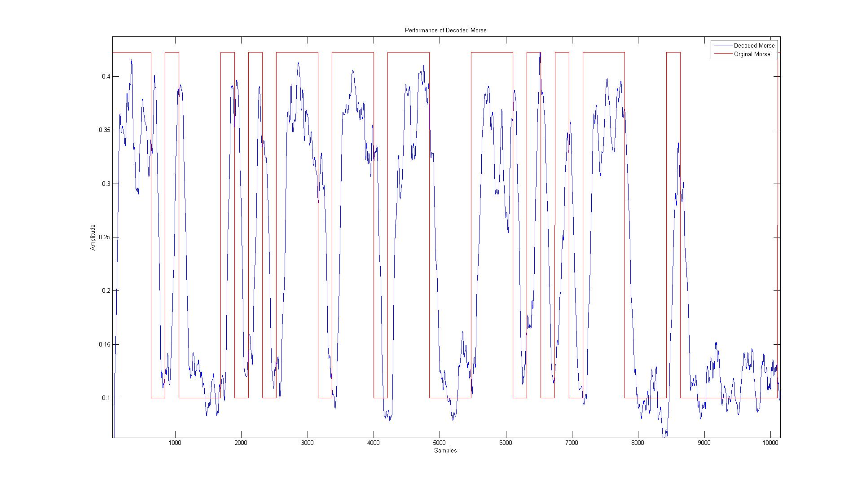

Figure : Performance of Morse Decoder at SNR= -3dB.

1. References